Michigan Teachers Co-author a Differentiated Instruction Book for World Languages
By Taru Nieminen
March 15, 2013
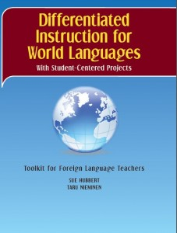
Rockford, MI -- Sue Hubbert, M.A., and Taru Nieminen, M.A.T., have written and published a supplementary activity book for world language teachers using differentiated instruction methods. Their toolkit for foreign language teachers is based on National Standards for Foreign Language Learning as well as the Common Core Standards. Each activity page includes ready-made assessment rubrics which support both standards. This book supports and expands the curriculum of any world language program.
Sue and Taru have found in their teaching that “more learning occurs when activities and projects are student-centered”, not teacher-driven and they wanted to share their discovery. Projects are all student-centered, student-generated, fun, interesting, and most of all, challenging. The projects address the individual needs and abilities of all students’ learning styles by providing choices for students and teachers.
From the Authors
“Our toolkit includes engaging, supplementary activities to foster critical thinking, creativity, responsibility, and independence in a foreign language classroom.”
What’s next?
The duo is currently working on their next book which is geared for ESL learners with the same emphasis on differentiated instruction. The supplementary activity book is scheduled to be released by May 2013.
About the Authors
Sue lives in Belding and Taru lives in Rockford; they are alumni of Michigan State University and Aquinas College, respectively. Sue has taught Spanish and English in the middle and high school levels for over 30 years as well as having adjunct professorships in area colleges. Taru is a multilingual from Finland and has taught in area elementary and middle schools since 2007 using differentiated instruction throughout her teaching.
Differentiated Instruction for World Languages With Student-Centered Projects is available online at Teachers Pay Teacher or link through our website to Amazon.com: http://WLToolkit.com .

